**Embedded Challenge Fall 2023 Term Project.**

**Group: 49**

Alston shi - as13388

Chinmay Prashanth - cp3873

Leshan Wang - lw3423

1. Introduction:

The objective of this semester's embedded challenge or term project is to create a wearable speedometer capable of calculating the overall distance traveled without relying on a Global Positioning System (GPS). Instead, the speedometer will utilize the data obtained from a built-in gyroscope, specifically the L3GD20, which can measure three-axis angular velocity. By strategically positioning the gyroscope sensor on the wearer's legs or feet, it becomes possible to capture angular velocities. With appropriate processing algorithms, these angular velocities can be converted into linear forward velocity and subsequently used to calculate the distance traveled, all without relying on external GPS data.

1. Calibration:

We implemented a calibration program to eliminate the fluctuation of the raw data. By doing this before actual measuring distance will help us to get more accurate data. The calibration program runs a similar logic to the actual measurement function. It gets the readings from gyroscope first without moving the chip and stores the aggregated data into a variable. After 4000 iterations, the program stops reading and calculates the average of the data (moving distance), the result is used as an offset for the actual measurement program when calculating distance. The calibration function has been proved very useful and has given very accurate measurement results in the final tests.

1. Main-Methodology:

Our initial step was to ensure seamless communication between our wearable device, the gyroscope sensor, and a display screen. To achieve this, we integrated essential libraries into our project, as discussed or explained in recitations. Additionally, we harnessed the capabilities of a customized header file ("LCD_DISCO_F429ZI.h") to efficiently manage the display and set up text buffers for presenting data.

The crux of our methodology is centered on transforming gyroscope data, which primarily captures rotational movement, into meaningful distance metrics. A carefully crafted algorithm facilitated this transformation process. Instead of measuring spinning motions, our algorithm ingeniously approximated real-time distances traveled by utilizing leg length and angular velocity. We’re using the data from the Z-axis of the gyroscope since we’re mounting it on the side of the leg, we’ve assumed that the distance traveled by the user in one step is the length/distance between the stationary leg and the moved leg. We can calculate the distance by a simple arc formula while considering the gyroscope reading and its sensitivity.

**Distance/Length = (2*ℼ*(leg length)/360)*(reading)*(sampling frequency)*(sensitivity)**

**Reading: real-time from the Z-axis of the gyroscope**

**Leg length of 1 foot is considered**

**Sampling frequency: 0.05**

**Sensitivity: based on 245 dps - 8.75 mdps/digit - From Datasheet**

Finally, the same concept was implemented in calculating the distance every time the gyroscope moved and data was read and made to output the distance traveled on the on-board display of the STM32-Board.

What truly set our project apart was its practicality and versatility. By bypassing GPS technology in favor of the gyroscope, we not only conserved power but also expanded the potential applications of our wearable. It could be utilized indoors or in scenarios where GPS signals were unreliable. Our project exemplified embedded systems' adaptability and real-world utility, demonstrating their relevance in various contexts, from fitness tracking to data-driven wearables. In essence, we succeeded in creating an innovative wearable speedometer that seamlessly integrated sensor technology, data processing, and user interface design.

1. Results:

We were successfully able to obtain a distance over two trails:

Trail 1: Demo Video - [Trail_1](https://drive.google.com/file/d/1ed2W2GVh9dbZElGIpdfrGUtzHEZhGe3i/view?usp=sharing)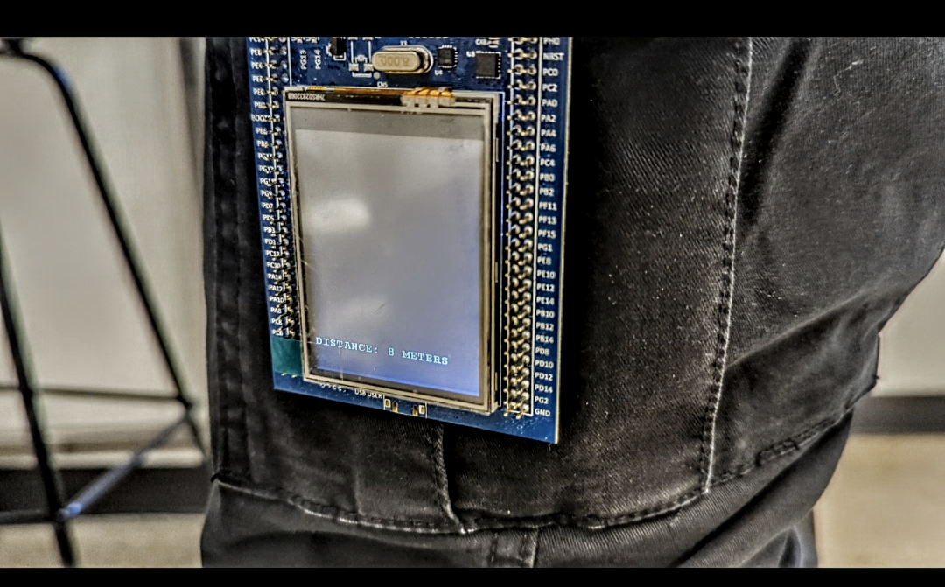

Trail 2: Demo Video - [Trail_2](https://drive.google.com/file/d/1oYRr6uf2MepJ-AuE0WHytOkOGuITbkBf/view?usp=sharing)

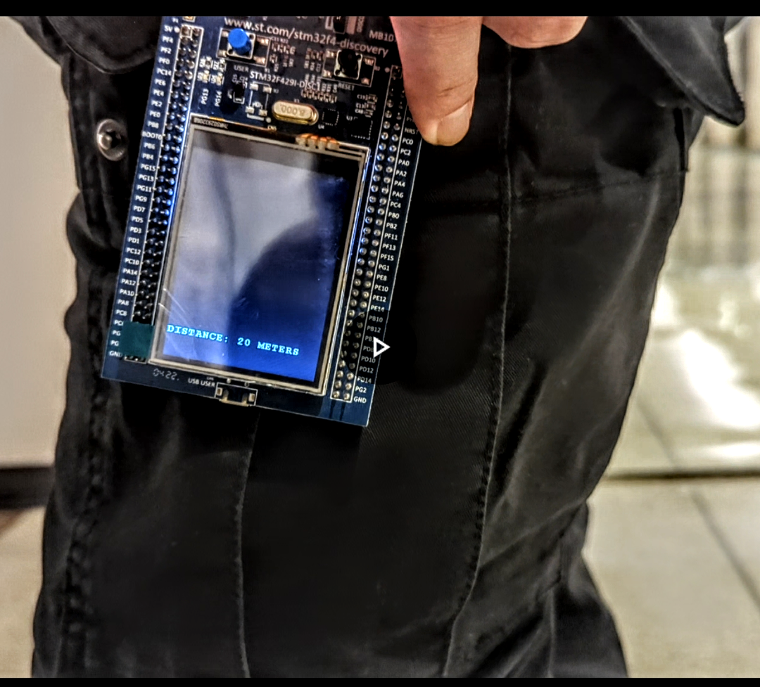

Output Displayed on screen

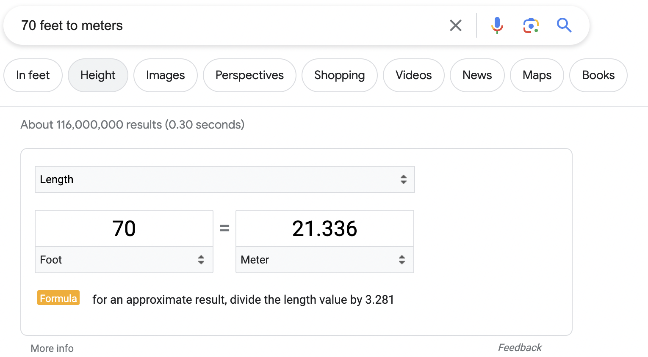

Actual Distance and Measured Distance